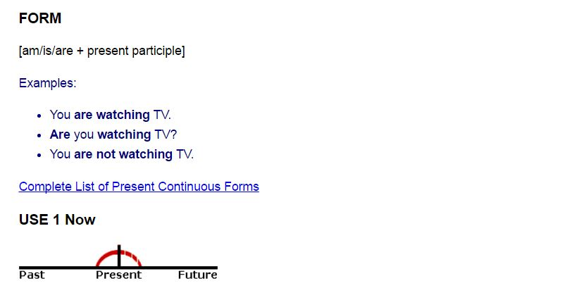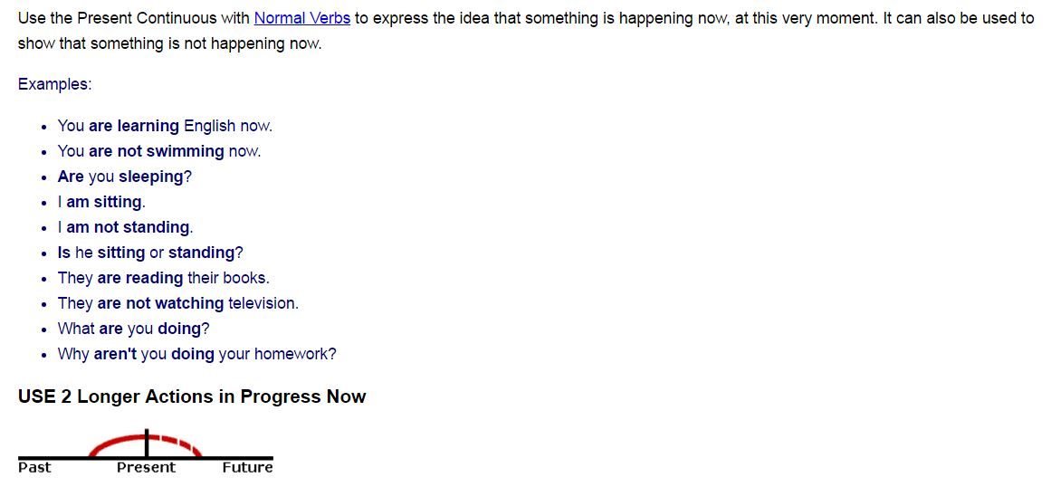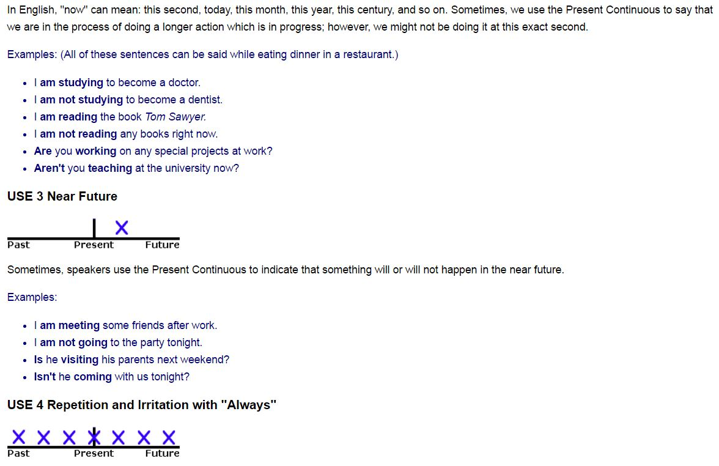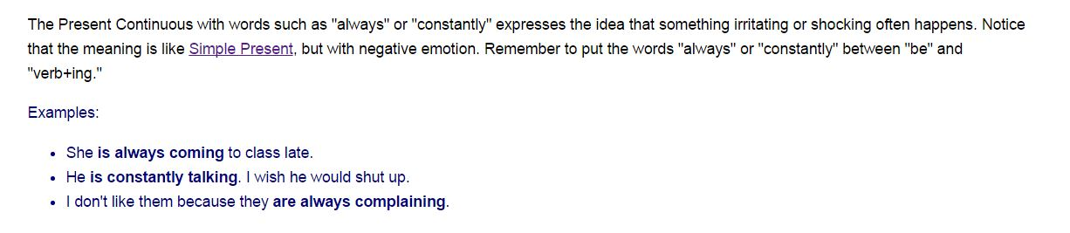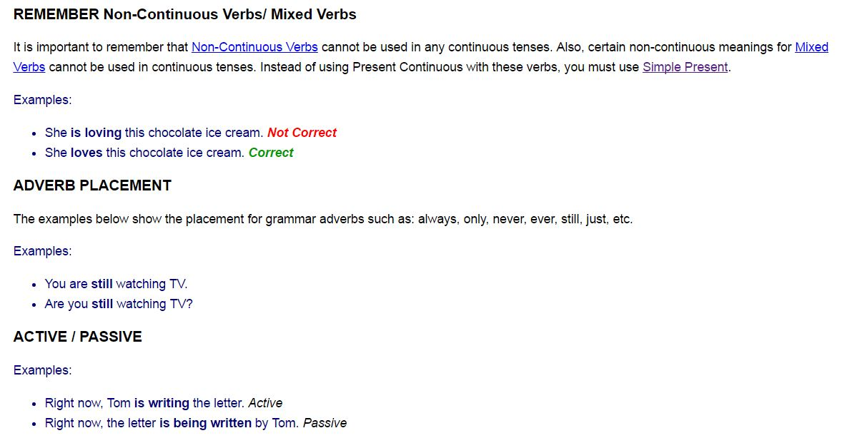

Using the words in parentheses, complete the text below with the appropriate tenses, then click the "Check" button to check your answers.

1. Every Monday, Sally (drive) her kids to football practice.
2. Usually, I (work) as a secretary at ABT, but this summer I (study) French at a language school in Paris. That is why I am in Paris.
3. Shhhhh! Be quiet! John (sleep) .
4. Don't forget to take your umbrella. It (rain) .
5. I hate living in Seattle because it (rain, always) .
6. I'm sorry I can't hear what you (say) because everybody (talk) so loudly.
7. Justin (write, currently) a book about his adventures in Tibet. I hope he can find a good publisher when he is finished.
8. Jim: Do you want to come over for dinner tonight?
Denise: Oh, I'm sorry, I can't. I (go) to a movie tonight with some friends.
9. The business cards (be, normally ) printed by a company in New York. Their prices (be) inexpensive, yet the quality of their work is quite good.
10. This delicious chocolate (be) made by a small chocolatier in Zurich, Switzerland.

